Attachment 1 (Continued)

 | SADC AVIATION SAFETY ORGANISATION  (SASO) Manual  (Excerpt)

Annex 1 to Volume 1, Chapter 4 of the SASO Manual

SASO FIRST YEAR BUDGET



THIS IS A WORKING DOCUMENT

1. INTRODUCTION 3
1. INCOME 4
2. EXPENSES SUMMARY 5
3. INCOME AND EXPENSES GRAPHS 7
4. CAPITAL EXPENSES 8
5. SALARIES AND BENEFITS 9
6. OPERATIONAL COSTS 10
7. OFFICE FURNITURE 12
8. OFFICE EQUIPMENT 13
9. CONFERENCES AND WORKSHOPS 14

INTRODUCTION

This document is a proposal for the SADC Aviation Safety Organisation (SASO) Secretariat’s first year budget. The data contained herein is a result of thorough analysis and assessment of records gathered from the United Nations (UN), the Southern African Development Community (SADC), the Regional Tourism Organisation of Southern Africa (RETOSA), the Civil Aviation Authority of Botswana (CAAB), the South African Civil Aviation Authority (SACAA), SASO documents, as well as comparisons with international best practices

This document facilitates prioritisation and resource allocation decisions. The estimated expenditures are parallel to income deeming it a realistically achievable budget. SASO’s budget upholds prudency but still ensures the availability of all resources required for achievement of SASO goals. It is assumed that SASO's first year is financed by Member States' contributions only and that all Member States fulfill their financial obligations to the Organisation. Inflation and taxes were considered in preparing the budget and underestimation was inadmissible for the purpose of diminishing exposure to risks of being underfunded.

INCOME
Membership Contributions | Proportion | Contribution (USD)
Angola | 9% | 171,000
Botswana | 6% | 114,000
Democratic Republic of Congo | 6% | 114,000
Lesotho | 5% | 95,000
Madagascar | N/A | N/A
Malawi | 5% | 95,000
Mauritius | 6% | 114,000
Mozambique | 6% | 114,000
Namibia | 6% | 114,000
Seychelles | 6% | 114,000
South Africa | 20% | 380,000
Swaziland | 5% | 95,000
Tanzania | 7% | 133,000
Zambia | 6% | 114,000
Zimbabwe | 6% | 114,000
Shortfall | 1% | 19,000
Total |  | 1,900,000

Budgetary Notes

- These contributions percentages are from the COSCAP-SADC project document. They are what Member States are currently contributing to ICAO for the COSCAP project.
- Madagascar has been suspended from SADC and is not expected to contribute.
- There is a shortfall of 1%. Only 99% has been allocated to the Member States and that means that income is short of UD 19, 000. It is recommended that the percentage allocations are reviewed in order to absorb the 1%.

Other sources of funding as appear on the SASO Charter are:

- Charging consulting and training fees
- Grants and donations
- Other sources as may be deemed appropriate by the Ministers

Furthermore, SASO plans to charge a safety levy to be determined by SASO in agreement with Member CAAs, AOC holders and the airline associations.
A fee may be charged for services provided to non-members of SASO. This fee will be determined by the Organisation based on the kind of service provided. SASO will also look into acquiring grants and donations from organisations such as:

- The World Bank
- China Funding
- European Aviation Safety Agency
- International Air Transport Association
- International Civil Aviation Organisation
- African Union
- United States Department of Transportation

EXPENSES SUMMARY
 |  |  | All in USD
Main Item | Sub Item | Qty | Unit Budget | Total Budget
Capital
 | Office Rent | N/A (provided by host State)
 | Motor Vehicle | 3 |  | 120,000
 | Equipment |  |  | 52,118
 | Furniture |  |  | 55,400
 | Connections And Installations |  | 5,000 | 5,000
Capital Costs |  |  |  | 232,518
Contingencies |  | 10% |  | 23,252
Sub Total |  |  |  | 255,770
Human Resource Expenses
 | Salaries and Benefits |  |  | 694,803
 | Recruitment and Hiring (Assignment grants included) |  |  | 45,000
Sub Total |  |  |  | 739,803
Operational Costs
 | General Office Expenses |  |  | 183,800
 | Motor Vehicle Operating Expenses |  |  | 33,200
 | Professional Development & Training (tuition) |  |  | 16,000
 | Consultants and Professional Fees |  |  | 160,000
 | Travel (mission & training) |  |  | 140,000
 | Conferences & Workshops |  |  | 30,600
 | Legal Services |  |  | 145,925
 | IT Services |  |  | 99,602
Operational Budget |  |  |  | 809,127
Contingencies |  | 10% |  | 80,913
Sub Total |  |  |  | 890,040
Total Budget |  |  |  | 1,885,613
 | Rounded to: |  |  | 1,900,000

Budgetary Notes

*Office Rent: Office premises are to be provided by the Host State.
*Motor Vehicle: SASO will purchase three vehicles: One for the E.D. (USD80, 000) and two for SASO’s general operations (USD 20,000 each).
*Equipment: the Minimum Requirements list determines Equipment acquired. Quotations for required equipment have been obtained from various retailers and these were used to come up with the Equipment figure.
* Furniture: the Minimum Requirements list determines furniture purchased.
Quotations for required furniture have been obtained from various retailers (such as Executive Desk Company and others) were used in determining the furniture figure.
*Connections and installations: Figures from Botswana Telecommunications Corporation (BTC).
*Salaries and benefits: as per breakdown on the salaries and benefits section based on job evaluation and other factors stated in the SASO manual.
*Recruitment and hiring costs (Assignment grants included): These are costs for hiring a venue for interviews, costs of advertising positions, induction costs and assignment grants (a salary advance for the first month for employees who relocate to the host country).
*Conferences, meetings and workshops: The figures are based on COSCAP’s conference costs. The budget considers about 6 workshops for the first year.

INCOME AND EXPENSES GRAPHS
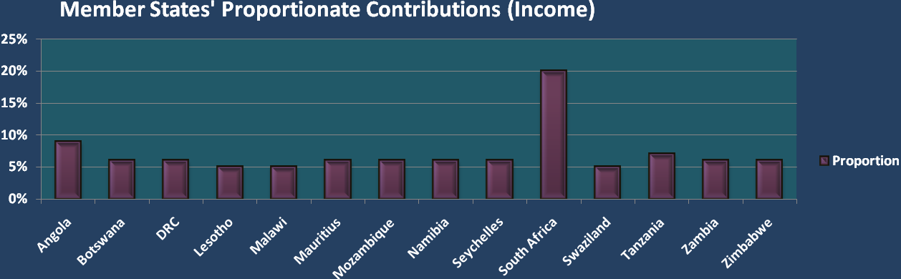

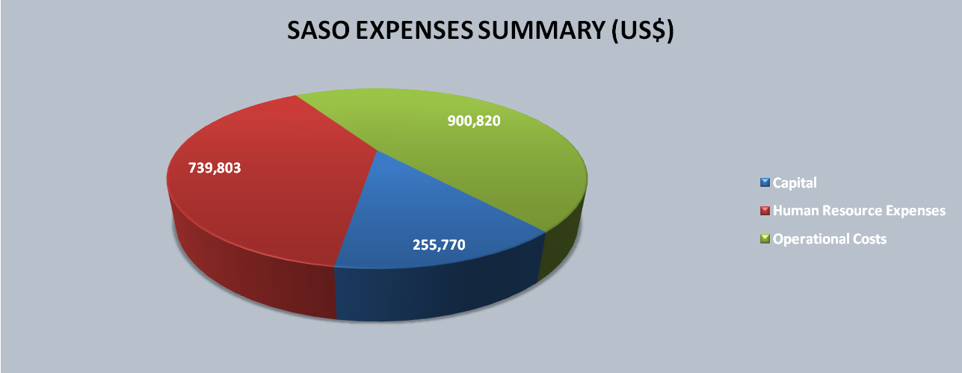

CAPITAL EXPENSES
 |  |  | All in USD
Main Item | Sub Item | Qty | Unit Cost | Total Budget
Premises
 | Office Rent | N/A ( provided by host State)
Motor Vehicle
 | Motor Vehicle | 2 | 20,000 | 40,000
 | Motor Vehicle | 1 | 80,000 | 80,000
Fixtures and Fittings
 | Equipment |  |  | 52,118
 | Furniture |  |  | 55,400
 | Connections And Installations |  | 5,000 | 5,000
Capital Expenses |  |  |  | 232,518
Contingencies |  | 10% |  | 23,252
Total |  |  |  | 255,770

Budgetary Notes
The SASO host state shall provide a building or adequate space in a building. The SASO facility should be of a size and configuration to accommodate the minimum requirements of the organisation as proposed by the SASO BUDGET.
However, The Host State is not obligated to provide any of the office furniture or equipment itemised. Furniture and office equipment will be provided by the SASO from its operating budget.

SALARIES AND BENEFITS
Maximum Salaries |  |  | All in USD
Main Item | Sub Item | Qty | Unit Cost | Total Budget
Salaries, Wages & Benefits
 | Executive Director | 1 | 174,498 | 174,498
 | Manager Tech Support & Training* | 1 | 165,773 | 165,773
 | Manager, Corporate Services | 1 | 118,857 | 118,857
 | Legal Advisor* | 1 | 145,925 | 145,925
 | Tech Coordinator OPS | 1 | 150,556 | 150,556
 | Tech Coordinator AIR | 1 | 150,556 | 150,556
 | IT Specialist* | 1 | 99,602 | 99,602
 | Secretary/Admin Assistant | 1 | 37,172 | 37,172
Sub Total |  |  |  | 1,042,940
For Required Positions |  |  |  | 631,640
Contingencies |  | 10% |  | 63,164
Sub Total |  |  |  | 694,803
Staff Recruitment Costs |  |  | 45,000 | 45,000
Total |  |  |  | 739,803
* Position not required for institutionalisation of SASO

Budgetary Notes

Information was gathered to model SASO’s staff salaries for the first year. Comparative organisations that were used resulted in a conclusion that the above salary packages are reasonable to institutionalize the organization. Comparator positions from organisations within and outside the SADC Region were used as a basis for the salary packages proposed above. The salaries for these positions were collected to design a sample where a market average was determined, resulting in the figures above.
The comparator companies/information used include: The UN Common Salary Scheme, RETOSA, ICAO and some CAA’s in SADC.

OPERATIONAL COSTS
 |  |  | All in USD
Main Item | Sub Item | Qty | Unit Cost | Total Budget
General Office Expenses
 | Stationery | 1 | 15,000 | 15,000
 | Telephone | 1 | 15,000 | 15,000
 | Internet Cost | 1 | 5,000 | 5,000
 | Printing | 1 | 120,000 | 120,000
 | Equipment Maintenance and Insurance | 1 | 7,000 | 7,000
 | Electricity | 1 | 8,250 | 8,250
 | Water | 1 | 500 | 500
 | Security | 1 | 6,000 | 6,000
 | Other services (Postal, cleaning, etc) | 1 | 7,050 | 7,050
Sub Total |  |  |  | 183,800
Motor Vehicle Operating Expenses
 | Fuel | 3 | 6,000 | 18,000
 | Licenses And Insurance | 1 | 15,000 | 15,000
 | Maintenance costs | 1 | 200 | 200
Sub Total |  |  |  | 33,200
Organisational Internal Services
 | Professional Development & Training (tuition) | 1 | 16,000 | 16,000
 | Consultants and Professional Fees | 1 | 160,000 | 160,000
 | Travel (missions & training) | 1 | 140,000 | 140,000
 | Conferences, meetings And Workshops | 4 | 10,100 | 40,400
Sub Total |  |  |  | 356,400
Total |  |  |  | 573,400
Contingencies |  | 10% |  | 57,340
Grand Total |  |  |  | 630,740

Budgetary Notes

* Stationery: The figures are from comparator organisations and enquiries from CAAB.
* Telephone: From comparator organisations and a quote from Botswana Telecommunications Corporation (BTC).
*Internet Cost: Based on a quotation from Botswana Telecommunications Corporation (BTC).
*Printing: Printing costs for one GSI course conducted by COSCAP were estimated at USD 30, 000. It is assumed that SASO will have four of these in its first year (30,000*4).
*Equipment maintenance and insurance: Based on costs of comparator organizations used.
*Electricity: Information based on the bills paid by CAAB. The highest monthly bill CAAB had paid at the time of preparation was P25, 000 a month. P25 000/6 wings (there are 6 wings at the CAAB Building and it is assumed that SASO’s office premises will be about 200m²) resulting in P 4,167 * 12 months =P 50,000/ 8 (currency conversion)=USD 6,250 + USD2,000 (allowance GSI courses printing strains, increase in electricity rates etc).
*Water: Cost based on enquiry from Civil Aviation Authority of Botswana (CAAB)
*Security: Budget for alarm systems and two security guards. Inquiry made at CAAB.
*Other services (postal, cleaning etc): Based on CAAB cost inquiry.
*Fuel: SASO will have three cars. The fuel figure takes into consideration current fuel prices and possible price increases. SASO will spend P4, 000 on fuel for each car on a monthly basis.
*Licenses and Insurance: comparator companies.
*Maintenance cost: looked into what maintenance brand new cars would actually need and suggest that UD 200 is sufficient for the first year.
*Professional Development & Training (tuition):
It is assumed that four individuals will attend four professional development and training courses within SASO’s first year. A training course is approximately UD 4,000. (4000*4)
*Consultants and Professional Fees: SASO will need the services of an Air Transport Economist. Research has shown that the appropriate budget for a transport economist for four months is USD 73,000. Allowance has also been made for payroll administrators, account opening charges etc.
*Travel (non- SADC missions & training): It is estimated that three people will attend four workshops/meetings/training in the first year. The travel figure caters for these three individuals’ air tickets, accommodation, Daily Subsistence allowance and terminal expenses. Traveling to expensive countries like Angola was taken into consideration, as well as travelling to other relatively more affordable countries. Allowance was also made for workshops and training that might take place out of the SADC Region, these will require more expensive flight tickets.

OFFICE FURNITURE
 |  |  |  | All in USD
Item | Description | Size | Qty | Unit Cost | Total
Coffee Table |  |  | 1 | 600 | 600
Conference Table - Set | Rectangular | Medium | 1 | 8,000 | 8,000
Bookcase | With Glass | Large | 1 | 2,500 | 2,500
Executive Desk |  |  | 1 | 4,000 | 4,000
Credenza |  |  | 1 | 2,000 | 2,000
Cabinet | 5 Drawer |  | 2 | 2,000 | 4,000
Office Chairs |  |  | 14 | 450 | 6,300
Work Stations | Lusk | seats 3 | 3 | 6,000 | 18,000
Miscellaneous |  |  | 1 | 10,000 | 10,000
Total |  |  | 25 | 35,550 | 55,400

Budgetary Notes

The above listed furniture is based on the Minimum Requirements Lists of SASO as suggested by the Steering Committee 9 of June 5 2012. The figures are based on research conducted on current market prices.

OFFICE EQUIPMENT
 |  |  |  | All in USD
Item | Description | Size | Qty | Unit Cost | Total
Desktop Computers |  |  | 8 | 2,500 | 20,000
Laptop Computers |  |  | 4 | 2,500 | 10,000
Printer/Copier/Scanner | Heavy Duty |  | 1 | 10,000 | 10,000
IP Phone |  |  | 9 | 200 | 1,800
Flip Chart Easel |  |  | 1 | 250 | 250
Flip Chart paper | 20 Sheets |  | 6 | 10 | 60
Computer Projector |  |  | 1 | 700 | 700
Waste Paper Basket |  |  | 9 | 5 | 45
Paper Shredder |  |  | 1 | 1,000 | 1,000
Fax Machine |  |  | 1 | 500 | 500
Projector Trolley | Oak | 550 x 465 800mm | 1 | 200 | 200
Projector Screen |  |  | 1 | 175 | 175
Projector Screen Tripod |  |  | 1 | 250 | 250
Fridge |  |  | 1 | 400 | 400
Computer Software |  |  | 1 | 2,000 | 2,000
Sub Total |  |  | 46 |  | 47,380
Contingencies |  |  | 10% |  | 4,738
Total |  |  |  |  | 52,118

Budgetary Notes

The above listed equipment is based on the Minimum Requirements Lists of SASO as suggested by the Steering Committee 9 of June 5 2012. The figures are based on research conducted on current market prices.

CONFERENCES AND WORKSHOPS
 |  |  |  |  | All in UD
Main Item | Qty | Unit Cost | Length | Subtotal | Total
IWG |  |  | Days
Workshop | 2 | 1,000 | 5 | 10,000 | 10,000
Printing | 2 | 100 |  | 100 | 200
Sub Total |  |  |  |  | 10,200
FSWG
Workshop |  | 1,000 | 5 | 5,000 | 5,000
Printing |  | 100 |  | 100 | 100
Sub Total |  |  |  |  | 5,100
CAST
Workshop |  | 1,000 | 5 | 5,000 | 5,000
Printing |  | 100 |  | 100 | 100
Sub Total |  |  |  |  | 5,100
Provision (2)
Workshop | 2 | 1,000 | 10 | 10,000 | 10,000
Printing | 2 | 100 |  | 100 | 200
Sub Total |  |  |  |  | 10,200
Total |  | 4,400 |  | 30,400 | 30,600

Budgetary Notes

The above are as explained on the Expenses Summary section of this document.

