

**SADC TRADE IN SERVICES NEGOTIATION**

**Draft Annex - Postal and Courier Services**

**Background Paper**

**_______________________________________________**

1. **Background**

SADC Member States have been negotiating specific commitments, i.e. market access and national treatment commitments, in the first round of negotiations launched in 2012 and due for completion in 2018. The negotiations on Lists of Commitments under this round cover six priority sectors i.e. communication, construction, financial, energy-related, tourism and transport services based on the World Trade Organisation (WTO) classification for services contain in document MTN/GNS/W/120. Postal and courier services is a subsector under communication services. At present, Member States’ Lists of Commitments covering horizontal section, and four sectors (communication, financial, tourism and transport services) are being legally scrubbed. Technical negotiations are ongoing on offers in construction and energy-related services.

In addition to Lists of Commitments, SADC Member States agreed to develop sectoral annexes to provide for regulatory disciplines to support liberalisation commitments and promote trade in the respective sectors. Annexes on movement of natural persons (mode 4) and tourism services have been legally verified. Technical negotiations are ongoing on outstanding articles in draft annexes covering financial and telecommunication services. Concerning an on transport and logistics services Member States are in the process of discussing the ambition and content of such an annex.

The draft annex on postal and courier services has been under discussion but it is yet to be accepted by all Member States. Some Member States expressed the view that adopting such an annex would send a wrong signal as the African Group’s position at the WTO was to oppose any consideration of negotiations and rule-making on e‑commerce. However, the key questions were on the link between the SADC and WTO processes and how the draft annex could contradict or frustrate the position of the African Group on e-commerce. Certain Member States acknowledge that there are could be spill-over effects of e-commerce on express delivery and tourism services but they did not establish a clear link to the content of the draft annex. Given these divergences, Member States were unable to reach consensus on how to proceed with the negotiations on the draft annex.

There is a need for Member States to understand the content and state of play in the WTO work programme on e-commerce and establish if there are any linkages between to the proposed SADC regulatory disciplines on postal and courier service. Also, comparable information on Member States’ national measures on the key provisions of the draft annex could be useful in addressing any concerns and guide the negotiations.

1. **Objective**

The objective of this paper is to provide information on the WTO work programme on electronic commerce (e-commerce) and national measures on postal and courier services in order to facilitate Trade Negotiation Forum (TNF) - Services deliberations for the finalisation of the draft annex on postal and courier services. Also, it assesses the link between e-commerce and the obligations set out in the draft annex.

1. **WTO work programme on E-commerce**

At the Second WTO Ministerial Conference in May 1998, Ministers, recognizing that **global electronic commerce was growing and creating new opportunities for trade, adopted the Declaration on Global Electronic Commerce.** The Declaration called for the **establishment of a work programme on e-commerce to examine all trade-related issues** relating to global electronic commerce, taking into account the economic, financial, and development needs of developing countries, and to report on the progress of the work programme. For the purpose of the work programme, e-commerce is understood to mean "the production, distribution, marketing, sale or delivery of goods and services by electronic means". Over the years, the WTO Councils on Trade in Goods, Services, and TRIPS explored e-commerce aspects with regard to the respective legal frameworks, with the Committee on Trade and Development addressing particular development aspects, the General Council looking at cross-cutting issues. In recent years, several WTO Members expressed an interest to explore the possibility of expanding WTO rules to address, inter alia, issues related to consumer and privacy protection, e-signatures cross-border information flows, data localization, cloud computing, cyber security, and e-payments.

Both the LDC and the African Group had reiterated that the Work Programme had no negotiating mandate and was meant to be exploratory in nature. Both groups have been approaching the exploratory discussions from a perspective that gives prominence to the development aspect of e-commerce. The African Group identified several priority areas including: the digital divide; the importance of digital rights, now that data is the raw material of the digital economy; the high market concentration levels existing in the e-commerce space; the range of attempts at a national level to shape digital flows. Inadequate infrastructure and low connectivity prevent LDCs and African countries from taking advantage of e-commerce, let alone rule-making. They urged Members to refocus the Work Programme on the development dimension of e-commerce with a view to building their e-commerce readiness and narrowing the digital divide. Discussions could focus, for example, on improved access to infrastructure, transfer of technology and the use of information technology in the integration of developing countries. They encouraged Members to share their experiences on the specific policy, regulation, and measures they had used to derive benefit at the national level from greater participation in e-commerce. African Ministers of Trade, in their Declaration issued in November 2016, had directed that any work undertaken within the WTO should be consistent with the African Union's Agenda 2063, with a view to structural transformation and industrialization in building "The Africa we want".

At MC11, Ministers adopted a Decision on the Work Programme[1], where they agreed to continue work under the existing mandate and to maintain the Moratorium until MC12. 70-plus delegations also issued a "Joint Statement on Electronic Commerce"[2], affirming their intention to "initiate exploratory work together toward future WTO negotiations on trade-related aspects of electronic commerce".

The work programme on e-commerce has not addressed postal and courier services in greater specificity. Some Members considered consider these services to be an indispensable element in the e-commerce ecosystem. The growth of e-commerce for goods generates demand for better postal and courier services that facilitates parcels delivery, both domestically and cross-border. Some Members claimed that developing the courier service sector could help take full advantage of opportunities brought about by e-commerce. In WTO discussions on e-commerce, China, for instance, had encouraged competition in the courier services sector.

1. **E-commerce, and postal and courier services**

The internet has changed beyond recognition the way that consumers carry out their shopping. Global e-commerce retail sales stood at $2307bn in 2017 and are set to rise to $4878bn by 2021. It is estimated that by 2022, cross-border retail will account for 20% of overall e-commerce, driven by the rising numbers of consumers in developing countries, where people are increasingly buying goods from online sources that are unavailable locally, with goods being shipped across borders directly to consumers. While communication in the form of letters and postcards has given way in large part to e-mails, texts and contacts through social media, lowering the need for traditional postal services, online shopping has given postal and courier services a new lease of life. Instead of eliminating the need for such services, the Internet is now offering opportunity. The rise of e-commerce and online shopping –– has the potential to generate huge new volumes of small parcels that postal services around the world are positioned to handle and deliver at low cost, in competition with commercial express delivery companies. It has been estimated that parcels and logistics contributed 17% of global postal service revenue in 2012, compared to just 9% in 2002, as e-commerce generates ever-higher volumes of small parcels flowing through the global system.

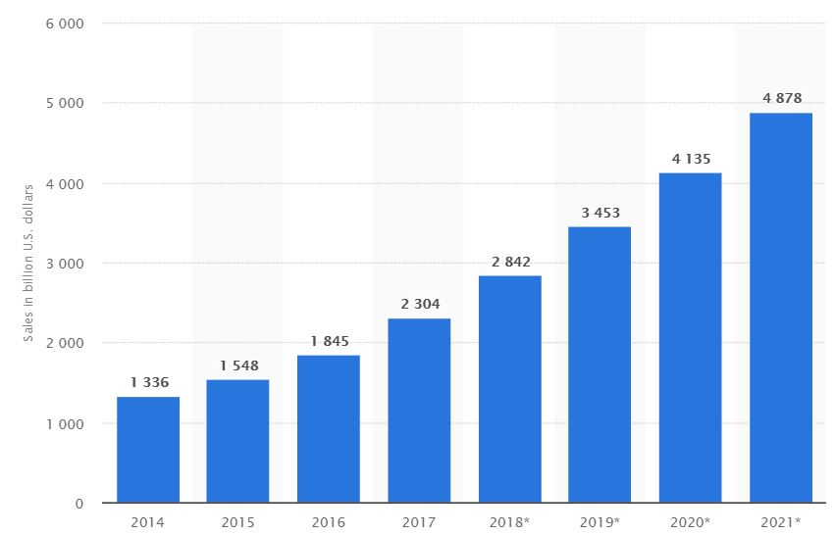

Worldwide ecommerce retail sales 2014 -2021 (in billion USD)

For example, in South Africa alone, there are currently estimated to be 18.43 million e-commerce [users](https://www.statista.com/outlook/243/112/e-commerce/south-africa#market-users), with an additional 6.36 million users expected to be shopping online by 2021, according to eShopWorld (see figure below). Four years from now, about 24.79 million e-commerce users will [spend an average of 189.47 USD online.](https://www.statista.com/outlook/243/112/e-commerce/south-africa#market-arpu)

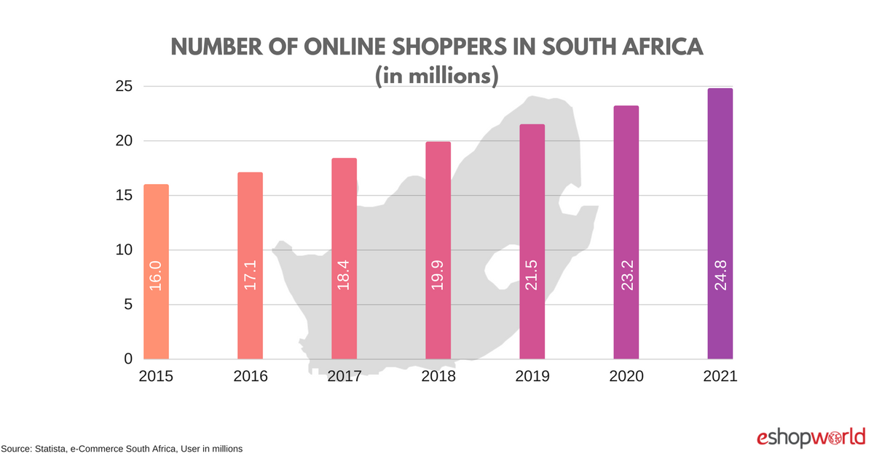

[Total South African e-commerce revenue](https://www.statista.com/outlook/243/112/e-commerce/south-africa#market-revenue) across all product categories is 2.69 billion USD, and is expected to grow to 4.7 billion USD by 2021. Electronics and Media is currently the leading product category in South Africa, accounting for 964.2 million USD market share, followed by Furniture and Appliances, which generates 553.7 million USD in sales.

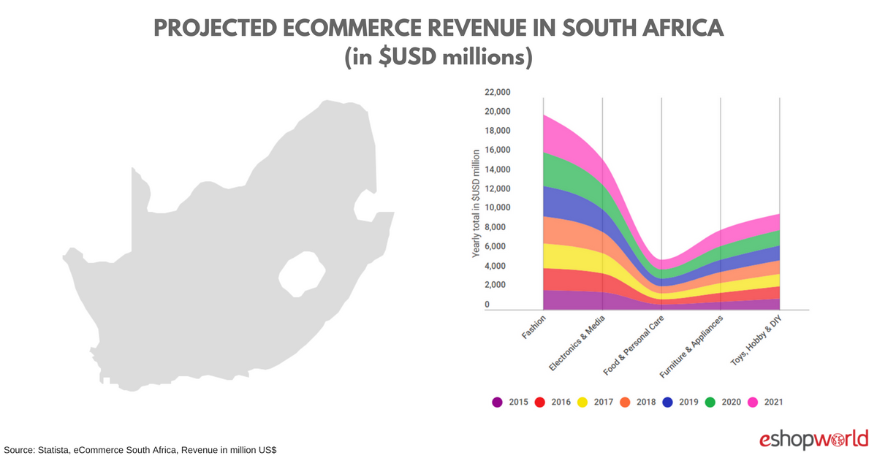

1. **Link between e-commerce and regulatory disciplines on postal and courier services**

The commercial links between postal and courier services and global e-commerce markets are not in doubt. Businesses offering online supply of consumer goods need postal and courier services to deliver such goods to the ordering consumers. It is clear that this form of commerce will put increasing pressure on traditional retailers.

The draft annex is informed by a SADC background study on postal and courier services, in 2012, which identified the need to address regulatory challenges encountered by traders in the sector. Given the fact that the SADC Protocol on Transport, Communication and Meteorology (TCM), to which not all Member States are party, contains agreement on policy and regulatory co-operation in postal services, the study proposed the development of an annex to the Protocol on Trade in Services (PTiS) focusing on pro-trade regulatory disciplines. The first Sectoral Focus Group on Communication Services under the TNF-Services agreed to develop an annex on postal and courier services that was separate from telecommunications. Hence, a draft text was developed based on principles found in the WTO reference paper on basic telecommunication services and regional business needs.

The provisions of the draft annex are built on the general obligations of the PTiS, with the aim of establishing clear pro-trade disciplines in regulating postal and courier services (see appendix 1). The underlying principles are explained as follows:

* ***Anticompetitive practices*** - Member States to maintain or introduce appropriate measures to prevent abuses of market position among postal and courier services providers by engaging in or continuing anticompetitive business practices.
* ***Universal service*** – reaffirming a Member State’s right to define the universal services obligations it wishes to maintain while ensuring objectivity, transparency and non-discrimination in application.
* ***Individual licences*** – limiting the requirement for individual licences for the supply of services within the scope of the universal service. It advocates the publication of criteria, terms and conditions as well as transparent and non-discriminatory licensing procedures.
* ***Regulatory body*** – aiming to achieve autonomy or independence of the regulatory bodies. It requires separation of regulatory role from services provision by ensuring the regulatory bodies are separate and not accountable to any supplier of postal and courier services.

The Annex disciplines are aiming to ensure transparency, abuse of market concentration and regulatory capture. They are building on regulatory principles that more than 100 WTO Members have embraced in the telecommunications sector and are not addressing issues dealt with under the WTO work programme on e-commerce, or explored by a sub-group of WTO Members for the purpose of future rule-making.

Table 1 show the current applied Member States regimes with respect to the obligations of the draft annex on Postal and Courier Services. Generally, most would seem already compliant to the obligations set out in the draft annex and they would not need to amend their existing regimes for implementation purposes.

**Table 1: Member States’ applied regime on the obligations of the draft annex**

| **Member States** | **Competition** | **Universal service obligation** | **Individual licence** | **Independent regulatory** |
| --- | --- | --- | --- | --- |
| **Botswana** | Competition Act No.17 of 2009  Communication Regulatory Authority (CRA) Act, 2012:   * S. 6 The Authority (Botswana CRA -BOCRA) shall … (c) monitor the performance of the regulated sectors in relation to levels of investment, …, competition, pricing, the costs of services, the efficiency of production and distribution of services and any other matters decided upon by the Authority * S. 89. The Board shall refer all issues relating to competition which may arise in the course of the discharge of its functions to the Competition Commission established under the Competition Act. | CRA Act 2012   * S.68 - Defines universal postal service (UPS) and the obligation thereof place under Designated Postal Operator (DPO) | S.67 of CRA Act Regulation 2017   * The DPO licence - provides for a postal operator to be designated to carry UPS obligations. | CRA Act, 2012   * BOCRA as postal regulator separate from Botswana post |
| **DR, Congo** | Law n°11-2009 of 25 November 2009   * Art. 5. Function of the authority (Agence de Régulation des Postes et des Communications Electroniques - ARPECE): * … guarantee the exercise of fair and healthy competition in the sectors of postal and electronic communications | *Loi N°10-2009 du 25-11-2009 portant règlementation du secteur des postes.*   * Art. 3 – defines UPS and further elaborated in article *7* * *Article 13 : L’opérateur postal en charge du service postal universel est désigné par l’Etat dans le cadre d’une concession.*. | Through concession | Law n°11-2009 of 25 November 2009   * ARPECE – independent regulator responsible for postal services, separate from National Post Office |
| **Lesotho** | Communications Act No. 4 of 2012 | ?? | ?? | Communications Act No. 4 of 2012   * Lesotho communication authority is responsible for the regulation of postal services |
| **Madagascar** | Autorité de Régulation des Technologies de Communication (ARTEC) | ?? |  | Loi n° 93 – 001 portant réforme institutionnelle du Secteurs Télécommunications et du Secteur de la Poste (Services Postaux, Service des mandats et Chèques Postaux)   * Ministry of Postal, Telecommunications and Digital Development is the postal regulator separate from “Paositra Malagasy” the public postal operator |
| **Malawi** | Communications Act of 2016   * S.55. (1) The Authority (Malawi Communications Regulatory Authority – MACRA) shall, in the performance of its functions under this Act, promote, develop and enforce fair competition and equality of treatment among operators in any business or service relating to the communications service sector | Communications Act of 2016   * S.155 – elaborate the scope of universal services, comprising of …   + 1 (f) - access to basic postal services and … * S.156 - Authority (MACRA) shall …   + (e) to designate one or more licensees to be in charge of the universal service or components of the universal service | Communications Act of 2016   * S. 124 – Public Postal services licence applies to UPS | Communications Act of 2016   * S. 121 MACRA independent regulator postal separate from Malawi posts corporation (DPO) established in S. 137 |
| **Mauritius** | Competition Act 2007   * S. 66 - The commission and regulators enter into MOUs … and establishing mechanisms for practical co-operation in the exercise of those responsibilities, incl. the use of sector-specific expertise of regulators w.r.t investigations under this act.   Postal Services Act 2002   * No specific reference | Postal Services Act 2002 – *Universal Service* means a courier or postal service which is reasonably accessible and affordable to any person within the State (Mauritius) on an equitable basis   * foresees that all postal and courier operators have to provide universal service | Postal Services Act 2002   * S.8 - 11 but S. 9(2) Minister may grant Mauritius Post Limited such exclusive right as a) operate a postal, courier or ancillary service, whether inland or foreign, within Mauritius … | Postal Services Act 2002   * S.4 - *Postal authority* (separate from Mauritius Post ltd) has powers to monitor, control, inspect and regulate postal, courier and ancillary services |
| **Mozambique** | No postal law?? |  |  |  |
| **Namibia** | Communications Act 2009  Establishes Communications Regulatory Authority of Namibia (CRAN)   * S.33-35 – promotion of competition | The Communications Act, 2009   * S.96 (2) When the Authority (CRAN) grants a postal licence, it may impose such conditions as may be necessary which conditions may relate to – * (a) the compulsory provision of such class of services as it deems necessary | The Communications Act, 2009   * S. 95 – no person except Nampost Ltd may render a postal service with license * regulation for courier services?? | The Communications Act, 2009   * CRAN is the independent regulator for the sector incl. postal … (courier services?) |
| **Seychelles** | Postal Sector Act, 2010   * S.23 - Functions of postal regulator * promote, develop and enforce fair competition and equality of treatment among licensees in any business or service relating to the postal sector | Postal Sector Act, 2010   * S.12.(1) - The Public Postal Operator (PPO) shall be the designated Universal Postal Service Provider | Postal Sector Act, 2010   * S. 13(3)(a) - PPO's licence * S.14 – conditions for PPO’s license | Postal Sector Act, 2010  S. 23. Postal regulator – functions   * (j) monitor, control, inspect and regulate postal, courier and ancillary services and ensure that these services are provided and operated |
| **South Africa** | Postal Services Act No. 124 of 1998   * S. 16 (6) - If it appears that the postal company or any other licence holder is taking or intends taking *any action which* has given or is likely to *give an undue advantage* to themselves or any other person or category of persons, the Regulator may, after having given the licensee an opportunity to be heard, direct the licensee in writing to *cease or refrain from taking such action***.** | South Africa Post (SAPO) is the only reserved postal service licensee – GN # 32859 of 10/01/2010 | Procedure and criteria specified in S.16 of Postal services Act, 1998 (amendment 2016) | Postal Services Act, No. 124 of 1998 - The Independent Communications Authority of South Africa (ICASA) is postal regulator *independent from SAPO* |
| **Swaziland** | Swaziland Communications Commission (SCCOM) Act No.10 of 2013   * S.6(l) - administer certain aspects of the Fair Trading Act, 2001, as they relate to the sectors regulated by SCCOM * S.7(s) - *ensure fair competition* in all Communications services, products, operations and activities which SCCOM regulates | Defined in licence issues under S.16 of SCCOM Act 2013 and elaborated in electronic Communications Act No.9 of 2013 | Electronic Communications Act 2013   * S. 31 – designated licensee(s) for universal services   Electronic Communications (Licensing) Regulations 2016   * S.5-10 - specifies the procedure, criteria, conditions etc. | SCCOM Act 2013   * S 3(2) … shall be *independent*in the performance of the functions of the Commission, and *shall not be subject to the direction or control of any person or authority* * S. 6(b) regulates and supervise provision of postal services |
| **Tanzania** | The Electronic and Postal Communications (EPOC) (Competition) Regulations, 2011   * S.5 - prohibits *anti-competitive agreements, arrangement or decisions, abuse of dominant* positions; anti-competitive *mergers, acquisitions, consolidations or takeovers; all other practices and acts* with an adverse effect on fair competition | Universal Postal Services (UPS) is defined in EPOC (Postal) Regulations 2011 - is *obligatory for**designated postal monopoly but can be provided by other suppliers* | EPOC Act 2010 – “individual licence” applicable beyond UPS to include network and content services EPOC (Licensing) Regulations 2011 - provide licensing criteria and conditions | EPOC Act 2010 and Tanzania Telecommunications Regulatory Authority (TCRA)   * regulates postal and courier services. TCRA is *not a service supplier or accountable to any supplier* |
| **Zambia** | Posta Services Act 2009   * S.4 (2) functions of the Authority (Establishes Zambia Information and Communications Technology Authority – ZICTA): * … (c) stimulate and ensure fair competition in the provision of postal and courier services | Posta Services Act 2009   * S. 1 – UPS – to be defined in the license * S. 24 – Zambia Postal Services Corporation or any other holder shall comply with conditions specified in the license to achieve UPS | Posta Services Act 2009   * S. 21 – license for reserved area | Posta Services Act 2009   * S.3 designate ZICTA as independent regulator of postal services * Postal Services (General) Regulations 2016 |
| **Zimbabwe** | Competition Act [Chapter 14:28]  Postal and Telecommunications Act, 2001  S. 4. Functions and powers of the authority (Postal and Telecommunication Regulations Authority - POTRAZ):  1) …(h) to maintain and promote effective competition between persons engaged in the provision of postal and telecommunication services and any activities connected therewith. | UPS - Not defined | Postal and Telecommunications (Postal Services) Regulations, 2001   * S. 4 - Postal service (general) licence - Currently Zimbabwe Post (ZIMPOST) is the DPO and the POTRAZ will not consider any application for this license category until further notice | POTRAZ – regulator of the postal and courier services operators |

1. Document WT/L/1032.
2. Document WT/MIN(17)/60.