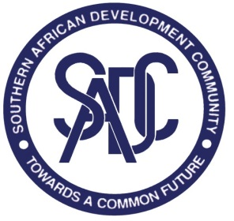
Developing SADC MRAs for professional services

Questions for professional regulatory bodies

- What occupation titles/categories should be covered?
- What activities are those occupations allowed to do in each state?
- What degrees or certificates are individuals required to have in order to be recognized?
- What are the modules/competences that are required for this degree?
- What are requirement for professional registrations?
- Which institution(s) is/are in charge of regulating the occupation titles?
- What “compensatory measures” are required if the applicants fall short of required degrees/certificate/registrations?
- How are continuing professional development (CPD) requirements treated?
- How does each regulator treat foreign trained pharmacists?
- What ethical requirements must be met?
- What is the disciplinary process in case of unethical conduct?
- What is the institutional framework to govern the process?
- How are disputes to be resolved?
- Who signs the agreement to make it binding on all regulators?
- Are there any other constraints/challenges that would impact the implementation and operationalization of the MRA?

