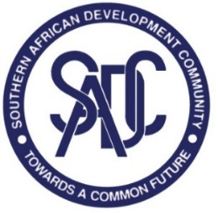

**TRADE IN SERVICES NEGOTIATIONS**

**1ST SECTOR FOCUS GROUP (SFG) MEETING – DISTRIBUTION SERVICES**

**6-7 NOVEMBER 2023**

**CAPE TOWN INTERNATIONAL CONVENTION CENTRE (CTIICC),**

**CAPE TOWN, SOUTH AFRICA**

**draft Agenda**

1. Opening Remarks
2. Adoption of the Agenda and the Programme
3. Objectives and status of Sector Focus Group
4. Election of Chair and Vice Chair
5. Context for SADC trade in services negotiations on distribution services
6. Introduction to distribution
7. Presentation of sector study on distribution services
8. Organisation of work and roadmap
9. Any Other Business
10. Adoption of the Report
11. Closing Remarks