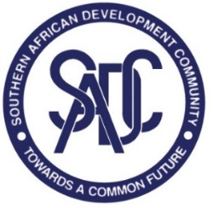

**TRADE IN SERVICES NEGOTIATIONS**

**1ST SECTOR FOCUS GROUP (SFG) MEETING –BUSSINESS SERVICES**

**8 NOVEMBER 2023**

**CAPE TOWN INTERNATIONAL CONVENTION CENTRE (CTIICC),**

**CAPE TOWN, SOUTH AFRICA**

**draft Agenda**

1. Opening Remarks
2. Adoption of the Agenda and the Programme
3. Consideration of the report of the 45th TNF-Services Meeting
   1. Decisions on development of SADC Mutual Recognition Agreement (MRAs) for Professional Services
   2. Draft roadmap for the negotiations on MRAs
   3. Reports of the 1st and 2nd dedicated session on Developing SADC MRAs for Professional Services
4. Consideration of the draft Guidelines for Developing SADC MRAs for Professional Services
5. Any Other Business
6. Adoption of the Report
7. Closing Remarks