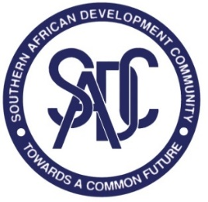

**46th Meeting of the Trade Negotiating Forum – Services**

**CAPE TOWN, SOUTH AFRICA**

**9-11 NOVember 2023**

**draft ANNOTATED Agenda**

1. Opening Remarks
2. Adoption of the Agenda and the Programme
3. Updates on Ratification and Accession to the Protocol on Trade in Services
4. Report of the First Meeting of the Sector Focus Group (SFG)-Distribution Services
5. Report of the Fourth Meeting of SFG-Business Services
6. Draft Guidelines for Developing SADC Mutual Recognition Agreements (MRAs) for Professional Services
7. Environmental Services: draft Study Report
8. Member States’ Requests and Offers for Liberalisation of Trade in Services:
   1. 1st Round Sectors: Angola’s Initial Offer
   2. 2nd Round Sectors: Member States’s Baseline Schedules and Requests
9. Update on Trade in Services Negotiations
   1. COMESA-EAC-SADC Tripartite Free Trade Area Agreement
   2. African Continental Free Trade Area (AfCFTA) Agreement
   3. General Agreement on Trade in Services (GATS)
10. Any Other Business
11. Adoption of the Report
12. Closing Remarks